“The Murder at Miniver Place”
A play

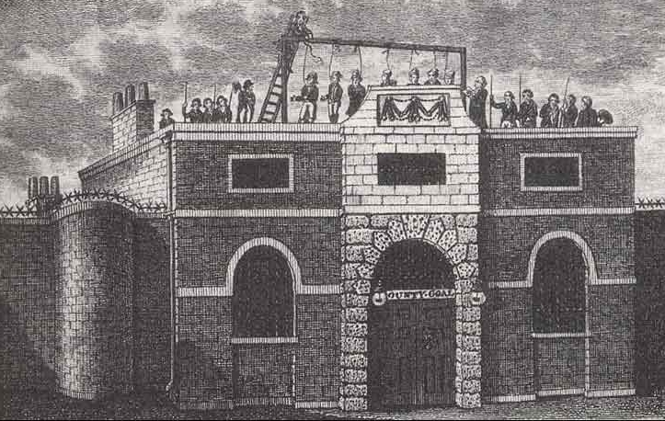
Horsemonger Gaol in Surrey, via capitalpunishmentuk.org

Character List
Maria Manning
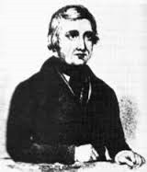
Frederick Manning
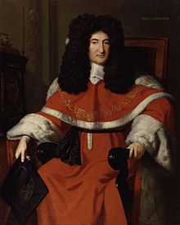
Chief Justice Cresswell

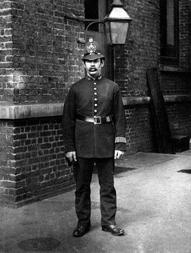
Henry Barnes- (policeman, K 256)
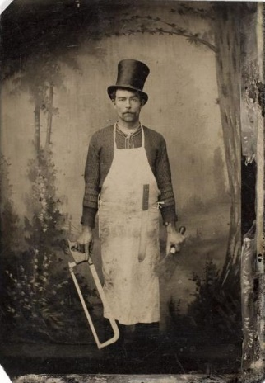
Lockwood- a surgeon

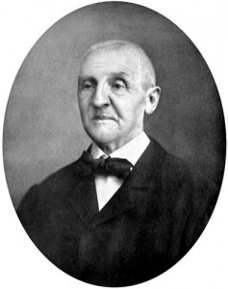
Sergeant Wilkins- a cross examiner

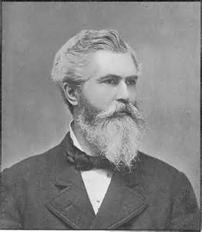
William Comley- the dentist
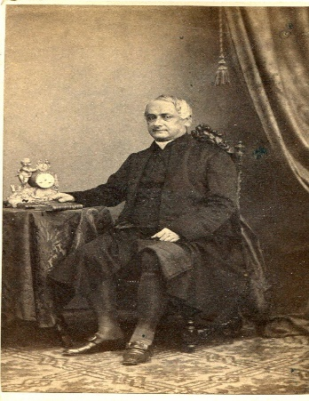
William Keating- customs clerk
Ann Harmes- landlady

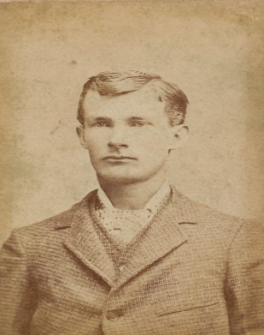
William Massey- medical student and lodger at the manning house
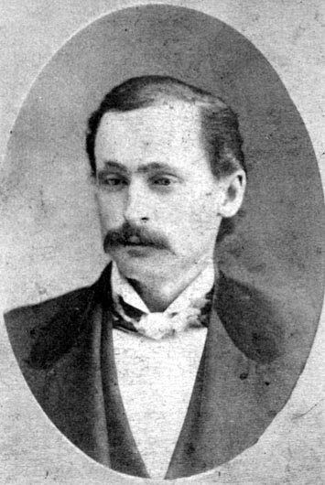
William Danby- a porter

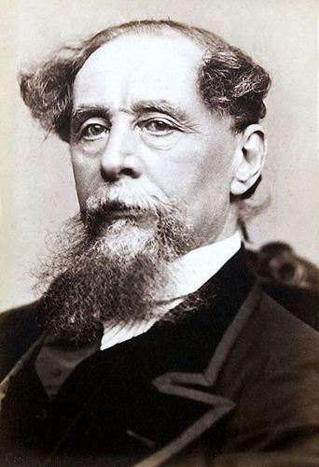
Charles Dickens- author and spectator to the Manning's execution

ACT ONE: SCENE ONE
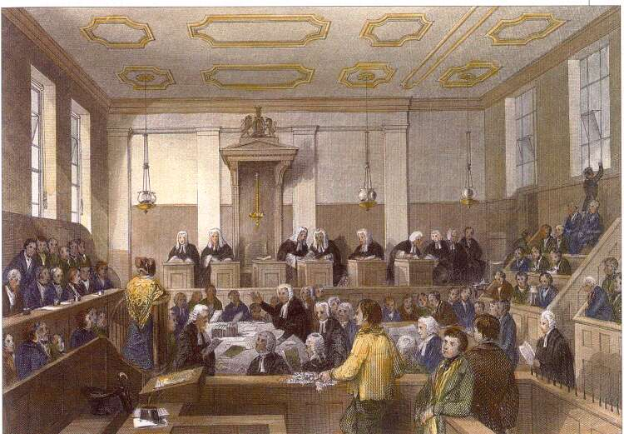
Old Baily Court Room, via https://janeaustensworld.wordpress.com
[The play begins overlooking an austere courtroom in Old Bailey Courthouse. The accused couple are a picture of contrast. Maria Manning seems to be calm and collected, almost bored. Her husband, however, paces wringing his hands and sweating profusely. Both plead not guilty. There is a large number of the public in attendance].
CHIEF JUSTICE CRESSWELL: I now call into order the proceeding of the trial on this day, the 25th of October 1849. The accused Frederick and Maria Manning are indicted for the willful murder of Patrick O’Connor. The first witness, Henry Barnes will now approach the stand. Please Burton, relate your part in the events that unfolded on the evening of August the 17th.
BARNES: “In consequence of information I received on Friday, 17th Aug. last, I went with Burton to No. 3, Miniver-place, Bermondsey—the house was empty—I examined and searched it—Burton [he gestures towards another man present in the courtroom] had opened the door with a key which he had in his possession—in the back kitchen my attention was attracted by a damp mark between the edges of two of the flagstones—I had heard that O'Connor was missing at that time—with Burton's assistance I removed the stones—there was mortar first under the stones, and then earth—the two stones appeared to have been recently removed—I proceeded to remove a portion of the earth—when I had got down about a foot, 1 discovered the toe of a man” (“Old Bailey” p.10).
CRESSWELL: A toe? The rest of the body was subsequently found. I presume?
BARNES: Yes, your honor. Mr. Lock-wood, the surgeon, brought in a troupe of his contemporaries unearthed the remainder of the body, removed it to the front of the kitchen, and then examined it in my presence.
SERJEANT WILKINS: [a cross-examiner begins to purse a line of questioning] “Tell me, as near as you can, what were the dimensions of the flag-stones?” (“Old Bailey” p. 12)
BARNES: “One was about two feet square, and the other about three feet long and two feet wide—they were thick heavy stones—I lifted them with a crow-bar—my brother constable, Burton, went out and borrowed one of some neighbor—the soil underneath was wet, it was maiden earth, such as would be filled in at the foundation of a house, lime-core, and clay” (“Old Bailey” p. 12).
WILKINS: So you would maintain that the cornerstones were quite cumbersome to lift? A nearly impossible job to complete on your own? You would say that you and your partner, Mr. Burton, worked together to accomplish this task?
BARNES: Yes, I daresay I would agree on all accounts.
[At this point, the focus shifts to the Manning’s, who up until this point had remained silent. At Wilkins implication that the murderers worked together, Frederick Manning lets out a startled cry and blanches rapidly. Maria Manning continues to stare at her husband quite unconcernedly, picking at her nails. Up until now, the husband and wife had sustained the claim the other had committed the murder.]
WILKINS: How was the body identified to be Mr. O’Connor?
LOCKWOOD: [the surgeon approaches the stand] I produced a set of false teeth from the body. Which I then gave to the dentist.
COMLEY: [the dentist now takes his place at the stand] “I knew the deceased O'Connor. On 17th Aug. last I went to 3, Miniver-place, Bermondsey—I then saw the dead body of Patrick O'Connor lying in the back kitchen—it was the same Patrick O'Connor who was a gauger of the Customs I had known him since 26th of last April, and had been frequently in his company. I saw him alive on 8th Aug.—I was with him at his lodgings, and accompanied him from there to Manning's house, 3, Miniver-place—I had been with him there before—Mrs. Manning let us in—it was about a quarter to ten o'clock—Mr. Manning was at home—we sat together for some time” (“Old Bailey” p. 23).
WILKINS: I’m not sure that I understand. What do the false teeth have to do with the identity of Mr. O’ Connor?
COMLEY: Well, I’m the one who made them for O’Connor. I’d be able to spot them anywhere. I am quite confused though, “as far as I had an opportunity of observing, the Manning’s were as friendly with O’Connor as brothers could be” (“Old Bailey” p. 23). Why would they murder him?

[The scene fades to black]

SCENE TWO
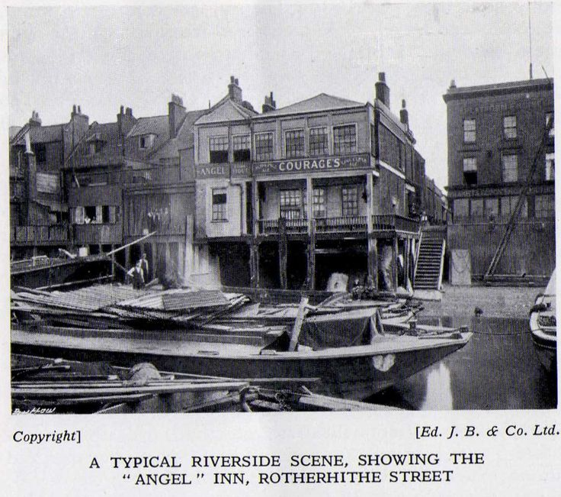
Angel Inn, via 1938 Official Guide to Bermondsey-Pictures of Bermondsey & Rotherhithe
[The scene opens with the stage bathed in dim morning light. It’s early May 1847. The couple is at the Angel Inn more specifically, Patrick O’Connor’s bedroom. Maria de Roux is hastily straightening her clothes while the half-dressed O’Connor looks on with a hooded gaze.]
PATRICK: My dear, remind me again why ever do you feel you need to make such a hasty retreat at such an ungodly hour?
MARIA: You very well know that I have a dress fitting today. I told you weeks ago that I decided to accept Freddy’s suit.
PATRICK: The insipid railway guard? He has a sponge where his spine should be. I genuinely thought you were joking when you said you were considering marriage. You know I am rather charming myself, I would be more than willing to take his place as your groom.
MARIA: Yes Pat, you lecherous old man, you’ve made your opinions about Freddy quite clear on several occasions now. But as I’ve said before, he is young, you are rather old. He is coming into his inheritance soon, and I can use his weakness of character and lack of moral fibre to my advantage in the long run. I’ve already explained my reasoning to you, but you are relentless. Remember, I don’t plan to alter our standing arrangement.
PATRICK: Yes, yes, I may be “a lecherous old man” as you put it, but I am an independently wealthy and dashing lecherous old man. You know that your bland “Freddy” will never be able to give you everything that you need.
MARIA: That very well may be so, but that’s what I have you for. [At this point Maria stops fidgeting with her stockings and abandons all hope of fixing her hair. She instead smirks sensuously at O’Connor and clambers back into bed where he still resides. All thoughts of a wedding dress fitting have been forgotten temporarily.]
Scene Break
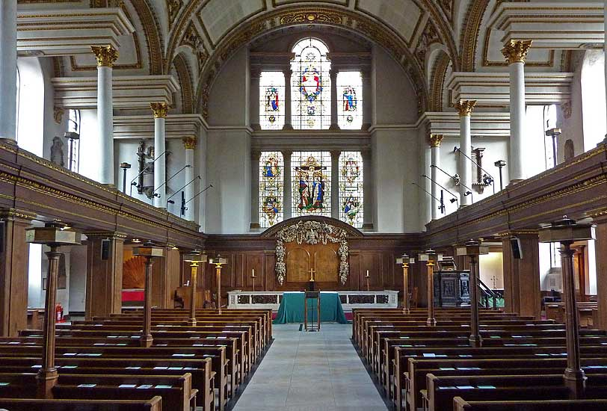
St. James Church, via http://www.flickr.com/photos/98115025@N00/385794815/
[The stage has gone dark for a moment. The lights brighten and Maria Manning re-emerges wearing a wedding dress. The backdrop: St. James Church, Piccadilly. She laughs in the arms of her new husband Frederick Manning. The audience celebrates and throws rice. Patrick O’Connor glowers from the edge of the stage, gripping the wedding announcement that he had received weeks two weeks prior, on the morning that he and Maria had spent at the Inn. The scene fades to black once more.]
SCENE THREE
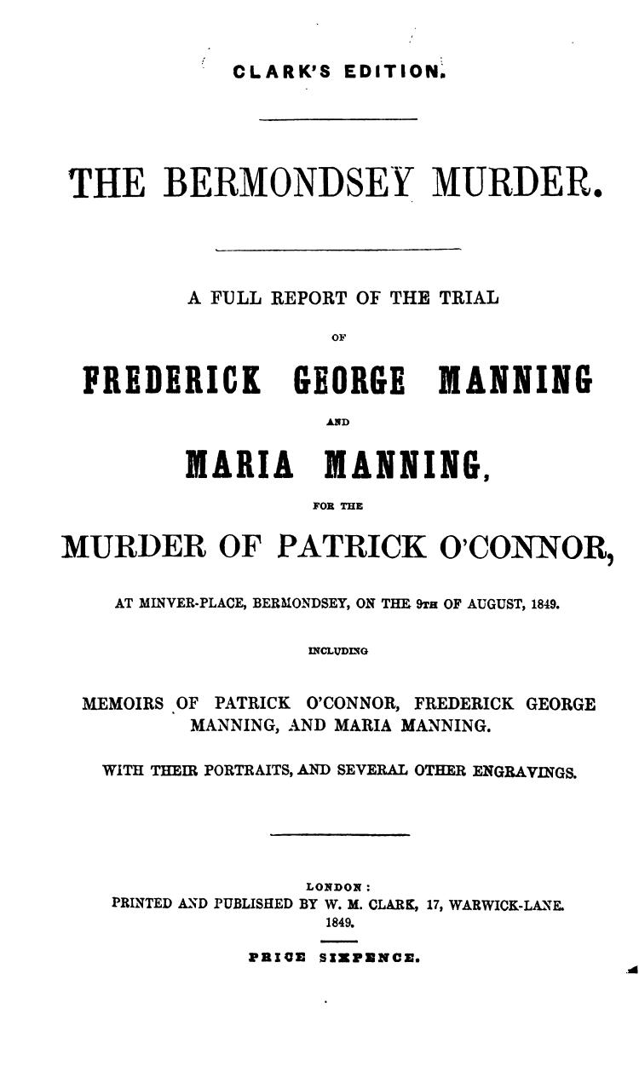
Cover of the Manning’s Trial Report, via https://archive.org/details/bermondseymurde00manngoog
[Witness accounts and testimonies continue to compile against the Manning’s].
WILKINS: Mr. Keating what is your relationship to Mr. O’Connor, and what pertinent information do you have to share with the court in regards to this case?
KEATING: “I am a clerk, in the Examiner's-office in the Customs. 1 knew Patrick O'Connor; he also held a situation in the Customs—I last saw him alive on the evening of the 9th Aug., on London-bridge, near the Surrey side; I think it was about a quarter to five o'clock, as near as I can tell—he was going towards Bermondsey—I was with Mr. Graham, also a friend of his—Mr. Graham had some conversation with him, and, in answer to a question of Mr. Graham's, he showed him a letter” (“Old Bailey” p. 26). Three days later, when O’Connor did not show up for work for sever days, I took it upon myself to go to Miniver House and see if the Manning’s had heard any news of his whereabouts, as I knew that he had dined with them three days prior. Upon answering my call, Mrs. Manning behaved oddly, claiming that O’Connor had not taken a meal with them on the ninth, even though I knew that on last seeing O’Connor, he was most certainly heading over to the Manning’s lodging. The letter O’Connor had shown Graham was from the Manning’s, it was a dinner invitation for that very night.
WILKINS: “I think you said that whenever you saw Manning with O'Connor they were on very friendly terms?” (“Old Bailey” p. 28)
KEATING: “Not very friendly terms, they appeared to know each other; they were not unfriendly” (“Old Bailey” p. 28).
[Three other witnesses attest to having seen Mr. O’Connor on the night of August the 9th, they also assert that he was most definitely headed to dine with Frederick and Maria Manning.]
ANN HARMES- [Mr. O’Connor’s landlady is called to the stand] “The deceased Patrick O'Connor lodged in our house nearly five years—he occupied two rooms on the first floor, on 9th Aug. I let him out at the shop door at half-past seven o'clock in the morning—I never saw him after that—he never returned to the house again—Mrs. Manning was in the habit of frequently coming to Mr. O'Connor—she came alone, except two or three times Mr. Manning came and some others. On Thursday, 9th Aug., I saw Mrs. Manning about a quarter before six; I saw her go upstairs—she went into Mr. O'Connor's room, and she remained there till a quarter-past seven. She came down stairs, came through the shop to purchase something of my sister. I saw her again on the next day, Friday—she came at a quarter to six, the same time as the day before, and she went upstairs as usual into Mr. O'Connor's room—she remained till over a quarter-past seven that day—I saw her leave the house, when she left I observed her shaking in tremor, particularly her left hand. Then Monday, the 13th some other persons came to the house, and went into Mr. O'Connor's room—they broke open a box in my presence—his cash box.” It is my presumption that as the box was empty, Mrs. Manning had removed its contents in the days prior (“Old Bailey” p. 43). [Harmes is reprimanded for her conjecture, but it seems by the general disposition of the jury that they agree with her theory.]
WILLIAM MASSEY: [a medical student and lodger at the Manning Home is called to the stand] “I knew O'Connor—I have seen him at Miniver-place three or four times—he appeared to be on good terms with the prisoners—the male prisoner has talked to me about O'Connor” (“Old Bailey” p. 53).
WILKINS: “Did he ever talk to you about laudanum or chloroform?” (“Old Bailey” p. 54)

MASSEY: “Yes, he did—he asked me in the first place, to the best of my recollection, what drug would produce stupefaction, or partial intoxication” (“Old Bailey” p. 54).
WILKINS: No further questions for Mr. Massey at the moment. I now call Mr. William Danby to the stand.
DANBY: “I am a porter in the employ of Mr. Evans, of King William-street—Manning came to the shop on 25th July, and I sold him a crow-bar—it was like this one (produced)—it was made from the same bar of iron, only it was five inches longer—we made it for him, and it was to be sent home to 3, Miniver-place, New Weston-street—I took it there on 28th July” (“Old Bailey” p. 60).
WILKINS: Did Mr. Manning tell you why he desired such an instrument?
DANBY: No, no he did not.
WILKINS: Would such an instrument be able to inflict the wounds seen on Mr. O’Connor’s head?
DANBY: It might have done so.
[Similarly, William Cahill, a shop man, gives a testimony that he sold a shovel to Mrs. Manning. It was subsequently found at the scene of the crime and was covered with the lime and mortar that Mr. O’Connor was buried in. A young neighbor was tasked with cleaning the kitchen, another suspicious action. At this point in the trial, Frederick Manning looks as though he’s about to become ill, and Maria Manning grows increasingly stricken. End scene.]
SCENE FOUR
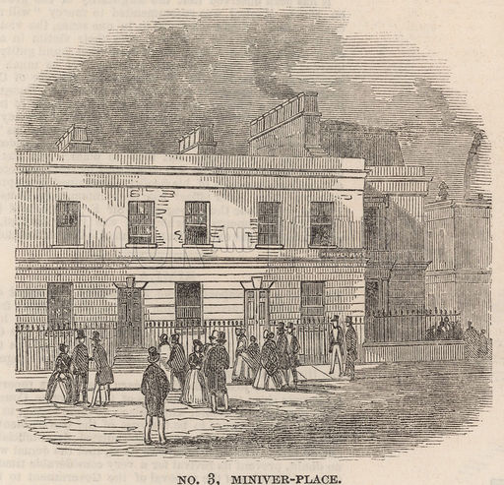
3 Miniver Place, London: scene of the murder of Patrick O'Connor by Frederick George Manning and Marie Manning; via The Illustrated London News, 1 September 1849.
[A rip-roaring fight has ensued between the young Manning’s. It’s a hot day in early June of 1849. While the nosy neighbors cannot ascertain precisely what the conflict is about, they can hear the muffled shrieks of Maria Manning, and see the wild gesticulations of Frederick through the windows which do not provide any coverage of blinds for the duo. Moreover, there is an occasional bang or shattering of glass.]
MARIA: [in a nearly hysterical voice] You told me you had an inheritance you buffoon! Why else would I have ever married a dimwit?
FREDERICK: [stuttering] Well, love, you see – I didn’t lie to you, per-say, -- however I did in fact stretch –
MARIA: [thundering] I don’t want to hear your pathetic excuses you imbecilic man! I want money! Or haven’t I made myself clear?
FREDERICK: [still demure] My dear, didn’t you say you had intentions of buying shares of stock in the railway from your friend O’Connor? It might take some time, but if we could invest properly over time we could incur--
MARIA: Freddy that’s it! You may be remarkably fatuous, but in this one instance you are ingenious!
FREDERICK: Yes, my sweet, I knew that you would see reason. We already have a reasonable some set aside, next week we can go to the clerk’s office and see about getting—
MARIA: No, no, no you simpering fool don’t you see? We do away with O’Connor!
FREDERICK: [wholly startled] Maria! Whatever do you mean? I’m quite convinced you’re infatuated with O’Connor. You never cease to flaunt your relationship with the man in front of me given half the opportunity! Hell, the man dines with us nearly every half a month!
MARIA: But Freddy this is our chance! Let me show you. [After hours of ranting, Maria takes a seat on the couch. She gently pats the space next to her in a conciliatory manner. Frederick remains dubious, but willing to make amends. He takes a seat and begins to help his wife hatch a murder plot. The neighbors outside are startled by the nearly sudden encroachment of silence, and continue to gossip about what may have spurned it. End scene.]
SCENE FIVE
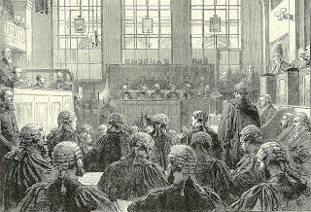
Old Bailey Courtroom, via http://victoriancalendar.blogspot.com
[The second day of the Manning’s trial has almost come to a conclusion. The masses are stirred up, and looking for a quick and harsh censure. There has been much speculation and talk about the relationships between all parties involved in the case. The public witnesses mill about outside the courtroom waiting for a conviction.]
WOMAN #1: Did you see the black satin dress Mrs. Manning was wearing each day of this cursed trial?
WOMAN #2: No, I didn’t, I could only focus on the cape! Did you hear, apparently on the first day of the trial, they brought in a chemist who took samples of what she was wearing the night O’Connor was murdered, he did experiments and found blood staining the satin. I wonder if she’s wearing the same dress today…
WOMAN #1: O’Connor was her lover, could you imagine what she would have done to her husband if had money?
WOMAN #2: Poor man, seems like he was confused accomplice in the whole thing, and can you blame him for finishing O’Connor off? The man was sleeping with his wife for godssake!
WOMAN #1: But the whole lot were friends! What a truly peculiar dynamic.
MAN #1: [interjects in the conversation] Thank the Lord that foul woman was Swiss. A foreigner. No one would want to sully the reputation of Englishwomen in association with the crime!
MAN #2: I do hope to get a decent view of the hanging! I’ll be taking my wife and kids, of course. It’s a good moral lesson. While women have the innate gifts of reaching such high levels of virtue, they also have much further to fall than those of my own sex (Knelman p.230).
[The public slowly begins to filter back into the courtroom. The wait isn’t long. It takes the jury just 45 minutes to reach a decision.]
JURY: [In a voice that is clear and sure]
FREDERICK GEORGE MANNING— GUILTY. Aged 30.
MARIA MANNING— GUILTY. Aged 28.
SENTACE- DEATH BY THE GALLOWS.
[At this pronouncement, Maria Manning loses her cool demeanor entirely, screaming and spitting, “Damnation seize ye all!” Frederick appears stunned. They are escorted from the building to their holding cells at Horsemonger Lane Gaol. End scene.] (“The Times” 1849)

SCENE SIX
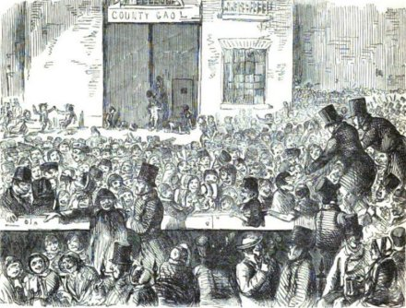
John Leech’s “Great Moral Lesson at Horsemonger Lane Gaol” appeared in ‘Punch’ magazine after the Manning execution and turned a critical eye not to the gallows, but to the crowd below.
[The brilliant and renowned author Charles Dickens sits hunched over a writing desk. He’s penning a letter to his friend John Leech, a reflection on the spectacle that was the Manning’s execution, which he then went on to post to The Times.]
DICKENS: [reading and revising aloud a draft of a letter]
My Dear Friend Leech,
Did you know 30,000 people attended the Manning’s execution? What an absurd concept. Why would anyone want anything to do with such a gruesome affair? People were selling food and drink, alongside homemade broadsides. An incredible feat seeing as some thoroughly detailed an execution that had yet to occur. Droves of people from all walks of life and rungs on the social ladder flocked together. Fights broke out, fainting’s were commonplace, and men and women alike bad crude jokes about the prisoners impending doom. My issue, is not necessarily with the punishment itself, but rather with how the crowds witnessing the spectacle comported themselves. "I believe that there was never a sight so inconceivably awful as the wickedness and levity of the crowd collected at that execution this morning. When the two miserable creatures who attracted all this ghastly sight about them were turned quivering into the air there was no more emotion, no more pity, no more thought that two immortal souls had gone to judgement, than if the name of Christ had never been heard in this world" (Storey and Fielding pp. 644-45). I do not know how to reconcile those persons that I have witnessed behaving in such a way with those who I know possess immeasurable amounts of good within themselves. The only way I can think to prevent such depravity is to end public hangings. The masses will never support this proposition, they treat hangings as one does a sport. They secretly enjoy this ghastly affair immensely. It’s a ritualistic way to justify their sadism and an easy form of entertainment. How is one to stand against such powerful desires? Leech, my good man, I implore you, help me to begin a campaign to put a stop to this madness. Any and all help you may provide would be most welcome.
Yours Most Sincerely,
Charles Dickens

Works Cited
Knelman, Judith. Twisting in the Wind: the Murderess and the English Press. University of Toronto Press, 1998.
Old Bailey Proceedings Online (www.oldbaileyonline.org, version 7.2, 04 October 2017), October 1849, trial of FREDERICK GEORGE MANNING MARIA MANNING (t18491029-1890).
The Times, 14 November, 1849, and in Graham Storey and KJ Fielding (eds), The Pilgrim Edition of the Letters of Charles Dickens, vol. 5, Oxford, 1981. Pp. 644-45.

